TNE20003 – Internet and Cybersecurity for Engineering Applications

Portfolio Task – Lab 2 Distinction Task

Aims:
- To subnet a network according to the given class address and network diagram

- Build and implement an addressed network according to the given network diagram below with addressing based on your subnetting in PT
- Achieve successful end-to-end connectivity of the addressed network implemented in PT

Preparation:
  - View “IP Subnetting"
  - & “IP address and subnetting task-1”
  - & “Network Addressing & Subnetting”
  - Using Self-Directed learning find out about Default Gateways
    - What are they?
A Default gateway is the access point in a network to communicate with other devices on different network.
    - What are they used for?
A Default gateways are used to forward the packet from local network to outside its network.
    - How do you implement them?
The default gateway can be configured on devices like routers, switches, or end devices (PCs and servers) by setting it in the network configuration settings or through CLI configuration.
    - Which device(s) are they placed on?
They are placed on Layer 3 devices, such as routers, switch and pc, to enable routing between different networks.
  - Using Self-Directed learning find out about static routes
    - What are they?
Static route is a manually configured routing entries, instead of dynamically generate information form routing protocols.
    - What are they used for?
Static routes are used to manage the flow of network traffic in simple networks because they allow direct routing to a specific network.
    - How do you implement them?
To implement static route need to config it manually by specifying the destination network with subnet mask and gateway.
    - Which device(s) are they placed on?
They placed on layer 3 device such as router and layer 3 switches.
  - Static routes are vital for you to be able to achieve end-to-end Connectivity.

Task Completion
- Upon completion of this task you are required to sit the online assessment relating to this lab under the “Quizzes” tab in Canvas. You will be awarded the grade if and only if you meet the requirements. If you do not meet the requirement you will be required to sit the online test for the lower grade. For example if you did the test for a D and did not get the 80% on the 2 attempts then you may take the test for a C.

Due Date:
- IT is advised that you complete the test at the end of the lab. If you do not then the absolute deadline is before the beginning of the lab in the following week.

Task 1.

Subnet and Address a Network According to Provided Requirements
In this task, you will
- Undertake the subnetting needed for the network shown in the diagram below and provide addressing for each network/subnetwork in the diagram below.

Instructions
1. Using the examples provided in the documents under the tutorial section under modules on Canvas for this unit, carry out the relevant subnetting to completely address the network shown below.

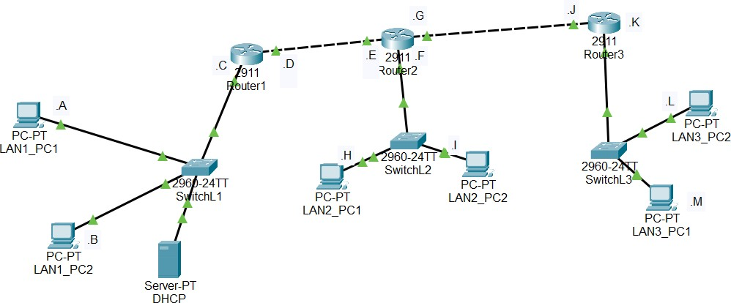
100.200.100.0/21

Some things you may want to consider are:

What class of network is the given address?
This is the class A network /21.

How many networks are shown in the diagram? Identify them on the diagram.
There are 5 networks in the diagram:
Network 1: Router1, SwitchL1, LAN1_PC1, LAN2_PC2 and Server P1
Network 2: Router 1 and Router 2
Network 3: Router 2, SwitchL2, LAN2_PC1, LAN2_PC2
Network 4: Router 2 and Router 3
Network 5: Router 3, SwtichL3, LAN3_PC1, LAN3_PC2

How many host addresses are possible per network/subnetwork?
The number of possible host address 254 hosts.

There are 5 networks:
2^3=8, so
21+3=24
32-24=8
2^8=256-2=254hosts addresses.

You must complete the subnetting before class and upload it to Canvas. Your lab instructor will check your solution and advise you of any problems.

Task 2.

Build your newly addressed network on PT
- Refer to Lab2 P if you need help on how to implement the network.

Instructions:

Carry out some basic connectivity tests.
  - Click on Lan1_PC1 and choose “desktop” and then click on the “command prompt”
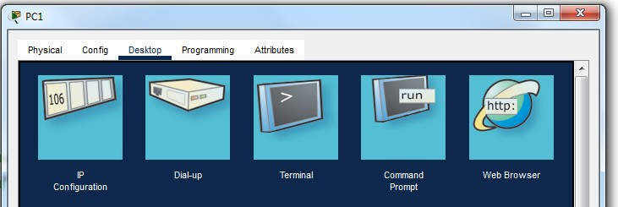

  - In the “command prompt” window type “ping Router1.C”

  - Note what is displayed. Did the ping work?
The ping is successfully working and getting the reply from Router1.

  - In the “command prompt” window type “ping LAN1_PC2”

  - Note what is displayed. Did the ping work?

The ping is successfully working and getting the reply from LAN1_PC2.

  - In the “command prompt” window type “ping Router1.D”

  - Note what is displayed. Did the ping work?
The ping is successfully working and getting the reply from Router1.D.

- Communicating to Router1.D
- From task 1 above you should remember that you were not able to ping Router1.D from either LAN1_PC1 or LAN1_PC2, but you were able to ping Router1.C.
- On Router1 issue the following command to enable you to see the ICMP traffic that is sent when you generate a ping or traceroute. Click on Router1 and choose CLI tab at the top. Press enter, then follow the commands in the graphic below:
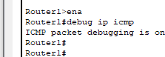
Note that to move from the viewer mode (Router1>) to the enable mode (Router1#) you need to type the word enable.
- Go to LAN1_PC1 and enter the following command ping Router1.C -n 10. This will send 10 ping packets to that n/w address. Then click on Router1 and look at the CLI screen. What do you see???
The CLM screen on router shown that “The ping is successfully working and getting the reply from LAN1_PC2 ” for 10 times.

- This output shows that the ping packets are being sent by the PC and are arriving at Router1. In Router1 hit enter a few times to enable you to separate the actions of the previous activity with the next one.
- Now go back to LAN1_PC1 and enter the following command ping Router1.D -n 10. This will send 10 ping packets to that n/w address. Then click on Router1 and look at the screen. What do you see???
The is not working because it is in the different network.
- What is different between steps c) and e) that might explain the different outcomes???

The difference between steps c and e:
Step c: the destination ip of Router1.C is within router 1 network.
Step e: the destination ip of Router1.D is in the different router 1 network, so the packet could not deliver.

  - You will need to investigate the reason for this outcome and troubleshoot it to find the solution and then implement the solution at each of the PCs on the 3 LANs.
There are five different networks in this topology, so after configuring the IP addresses and default gateways for all devices, they still couldn't communicate across the networks. I had to configure static routes on each router to make it work.

Once you can successfully communicate across Router1 to the address of Router1.D, then we can look at communicating to the end PCs of LAN2 and LAN3.
  - More self-directed learning will be required to determine how the packets can be transferred through the routers to the correct destinations.
  - Note that there are 2 possible ways of achieving this outcome. Please use the method outlined in the “preparation” part of this lab.

Once you have implemented the method in 2 above issue a ping from LAN1_PC2 to LAN2_PC1 and then LAN3_PC2.
  - Comment on the outcome of the ping.
The ping is successfully working and getting the reply.

Now issue the command “tracert” from LAN1_PC2 to LAN2_PC2.
  - Comment on the outcome of the tracert command.
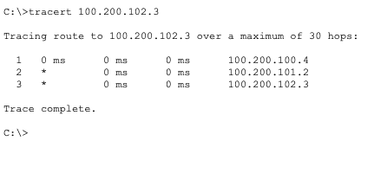

You should also investigate issuing a traceroute between all endpoints (ie PCs in different LANs) of your network and record your findings.

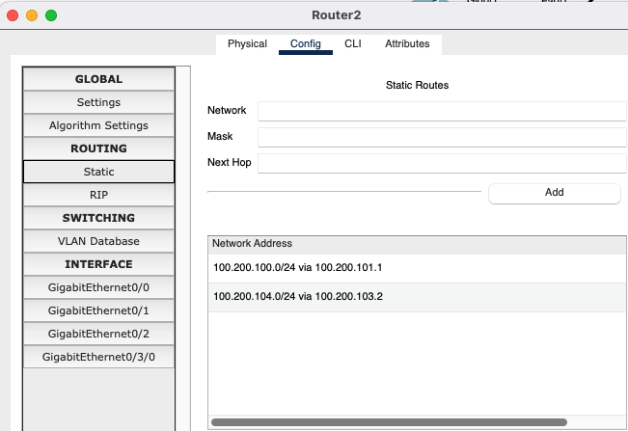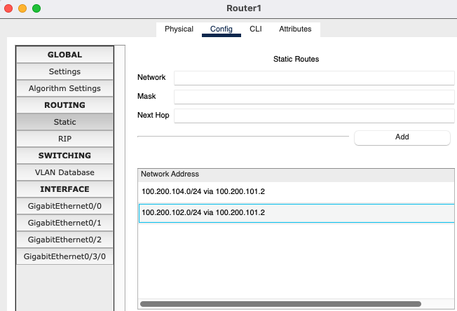

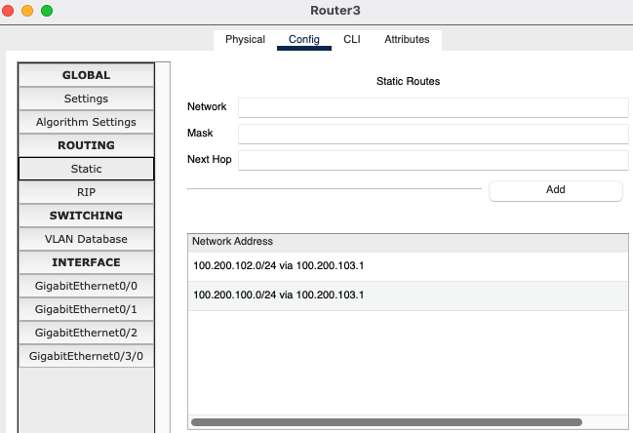

~~~~~ End of Lab ~~~~~

